The stakeholder system is presented through a web application, whose home login screen is represented below. All individual stakeholders will create an account regardless of whether they are the client, contractor, etc.

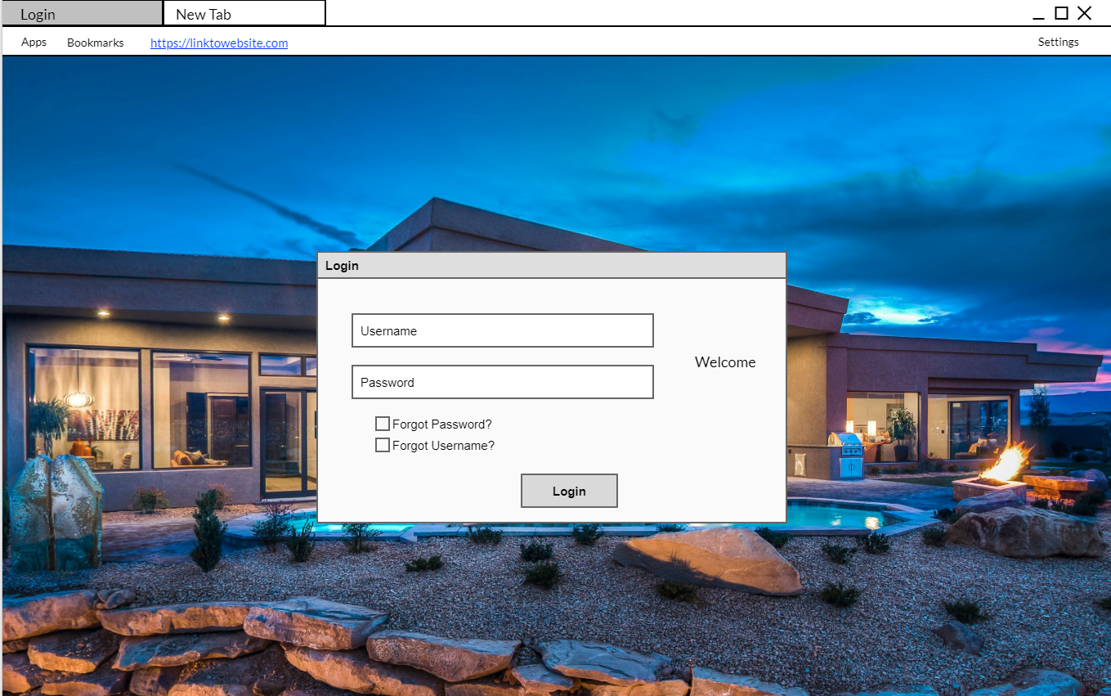

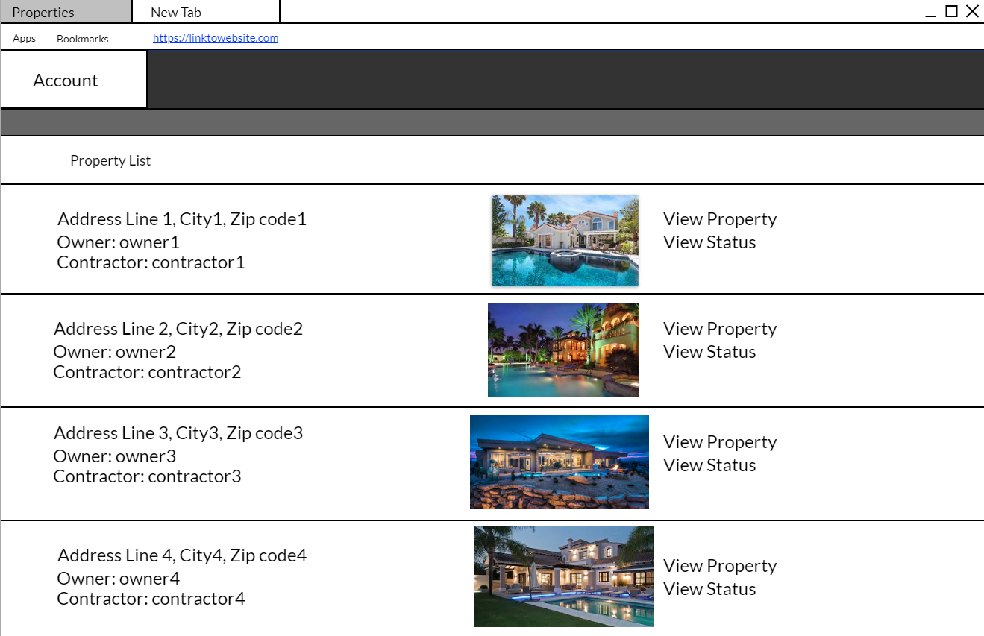One of the major features is for stakeholders like contractors or financial institutions to be able to view all their associated housing projects that they are involved in. For example, below would be the view of a financier, who can see the property and client and contractor, as well as the current build status/progression of the house.

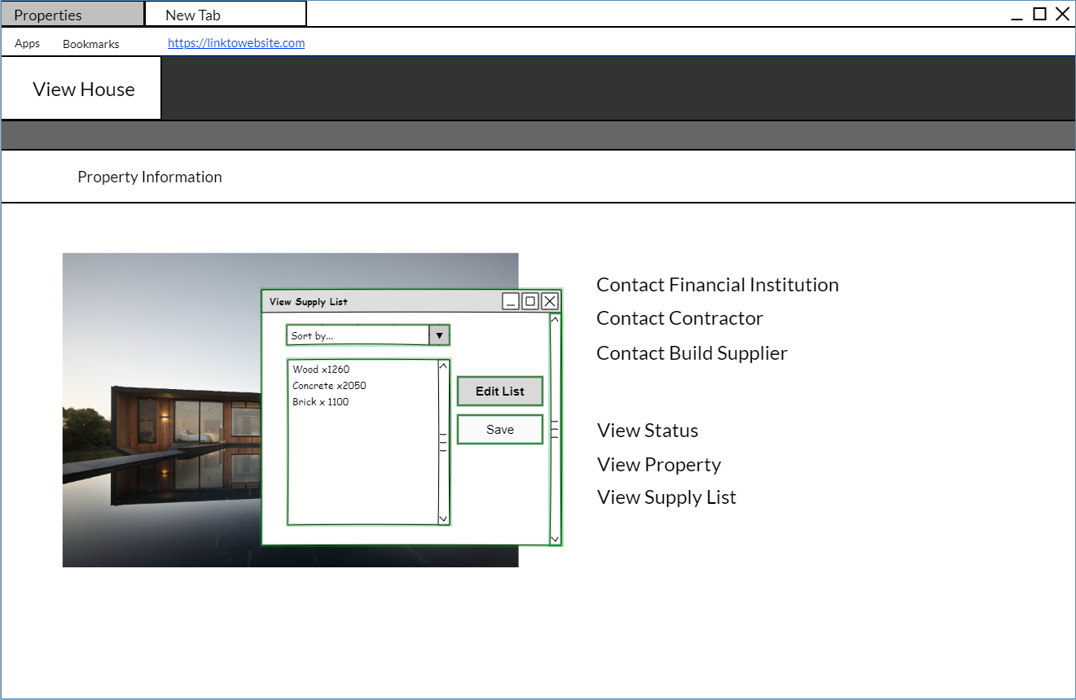A follow-up to the previous UI image, stakeholder like contractors and suppliers can view and edit supply lists for a particular house that they are responsible for. In addition, when viewing a specific property, the stakeholder can contact any of the other stakeholders on the same project/house. Individual status and property images can also be accessed.

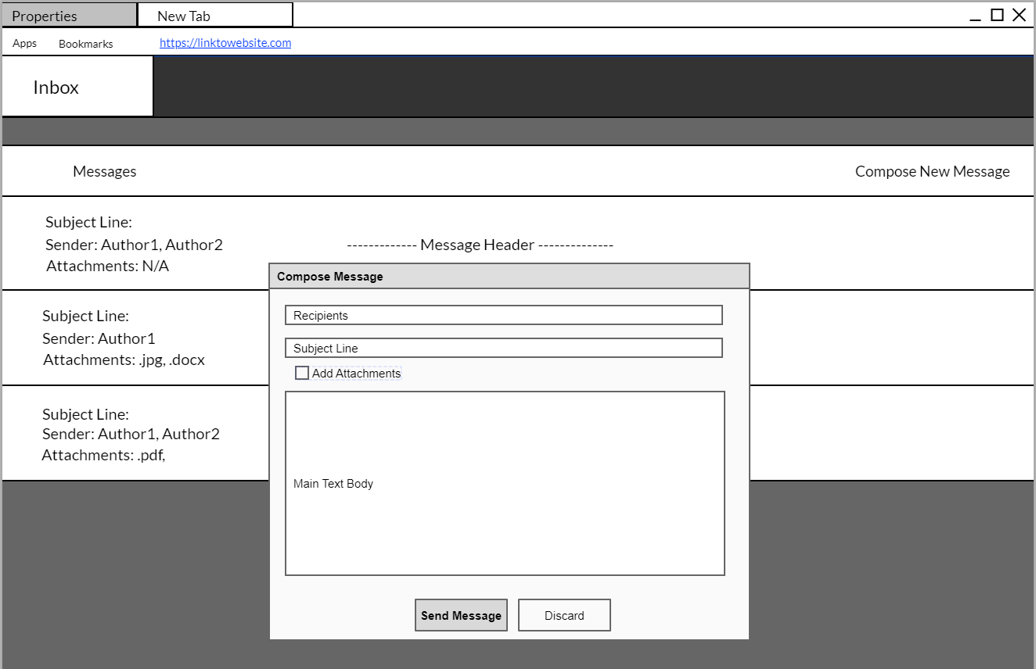Another key feature, is the ability to send messages to related parties via the Inbox. From the Inbox, any stakeholder can communicate with another; for example, if the contracting manager wanted to notify the supplier about restocking a specific building material, they could send a message directly to them. This is a simple, straightforward way for stakeholders to communicate.